BEACHPORT TRIP Friday 23- Monday 26 January 2026 (Australia Day long weekend)
Trip Report by Daniel Martucci

Participants:

- Tim Welch (Trip Leader) + daughter Hannah (4) 200 Series LandCruiser
- Craig Marchant 200 Series LandCruiser
- Grant & Louisa Selleck 150 Series Prado
- Bob Ellis 76 Series LandCruiser
- Steve & Pip Weston 200 Series LandCruiser
- Dave Hemsworth 250 Series Prado
- Shane Saxby & Meaghan Wotton + daughter Imogen GU Patrol wagon
- Geoff Green and passenger 300 Series LandCruiser
- Peter and Deb Young 79 Series LandCruiser single-cab
- Rob Zadow 200 Series LandCruiser
- Daniel & Sophia Martucci + kids Lara (8) & George (7) 79 Series LandCruiser dual-cab
- Greg and Trea (Shane’s tradie guests) Isuzu DMax or Ford Ranger dual-cabs

BLISTERING days of Adelaide heat was avoided – or so we thought – as our group retreated to the more civilised southeast on Friday 23 January 2026. This was the Club’s ‘annual’ pilgrimage to this lovely area of coast, offering what many consider to be among the top-three beach-runs in our country. Most arrived by the 6pm Happy Hour and found each other within part of Beachport’s Southern Ocean Tourist Park for this little shindig. Accommodation deployed for the three nights involved ranged from at least one swag and a camper trailer to caravans and cabins.

Saturday 24 January 8:30am: the briefing for our two days of 4WDing to come, courtesy of new Trip Leader Tim ‘O’ Welch – who had courageously put his hand up for the job, for the first time, after his first trip there last year, despite also even having to fly solo with his four-year-old daughter in tow. A sterling effort to get as far as that! Tim advised that tides – always a worry on these beaches – dictated a reversal of the original plan, with us now intending to go south to Carpenter Rocks on Saturday, and north to Robe on Sunday.

By 9:45am we had been briefed, paper work comleted, assembled, moved, aired-down and flagged-up ready for a tight convoy photo halfway down the beach from Beachport to Southend. That was like a highway, and one of the convoy pulled out just before the navigation got harder south of Southend. In the midst of this, many UHFs overheated, but many a mid-convoy U-turn was executed with aplomb.

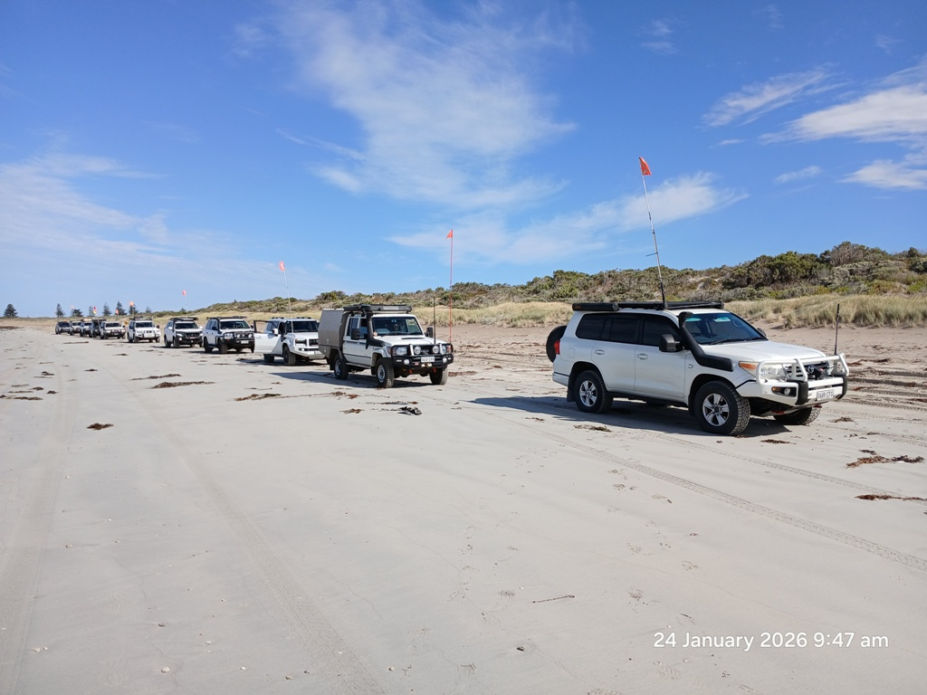

Unfortunately, we couldn’t have a peek at any of the beaches until negotiating about 20km of inland tracks south of Southend, with the temperature steadily rising. By 12:30pm it was 42 degrees, and Tim tried a beach access track – valiantly getting onto that beach, but immediately getting bogged on it too. Things were that awful combination of ‘steep plus narrow’, in this case with the added spice of ‘heat’ plus ‘a misleading set of tracks’ – which Tim reflected must have actually been from motorbikes riding very parallel. To recover Tim, Daniel got close enough to mark this occasion with the first use in anger of his winch, with advice from trained-wincher Bob. Oh well, it was time for lunch anyway, with some of the kids preferring a paddle instead of watching the action.

We were off again by 1:20pm, by which time a front appeared with overcast and even a few drops of rain, with temperature dropping to the mid-twenties. The temperature of torque converters in the 200s was another story, with Tim reporting his rig’s preference for low range when tootling around these inland tracks. Fortunately, no transmissions called it a day, but some others in the convoy did, turning back for an early finish.

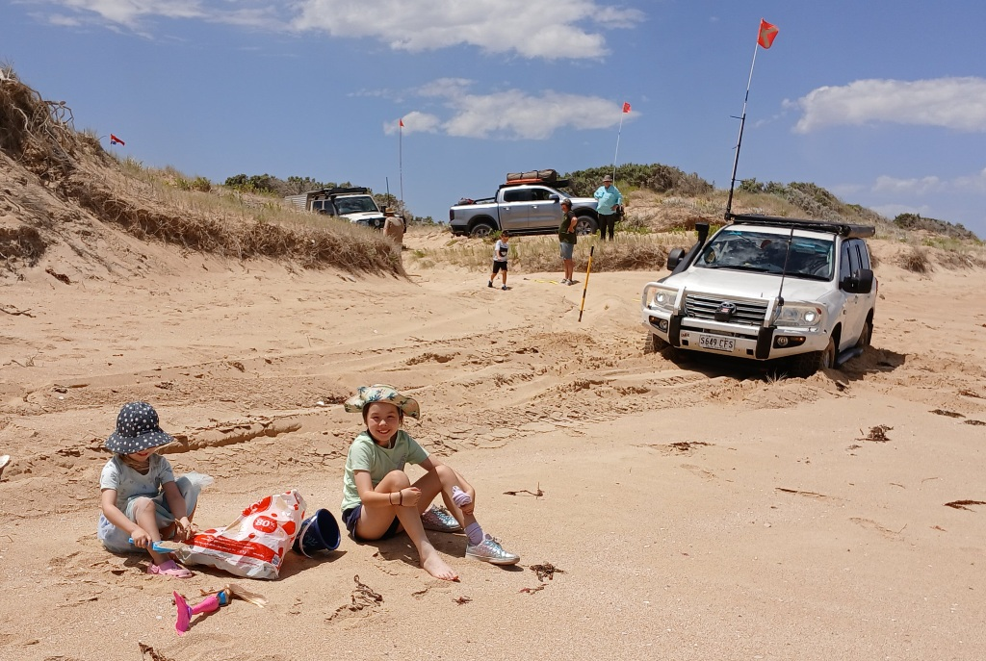

Another 12km south on Canunda NP’s inland tracks got us to the Number Two Rocks headland by 3pm, for what ended up being smoko. 11km further south and by 5pm, things wound up at the Cape Banks Lighthouse, just north of Carpenter’s Rocks, with Tim kindly issuing icecreams from the club as we then aired-up. Just north of this, Admella Beach unfortunately also had to be bypassed – this being named after the nearby 1859 wreck of the ship by that name. This was one of Australia’s worst maritime disasters, where only 24 out of 113 on board survived after clinging to the wreck on a reef 1km offshore for a week. By 7pm most were back in Beachport, ahead of the 7:30pm dinner at the Beachport Hotel. This was a nice group function and included celebrating Sophia’s birthday that day. The evening got chilly – a huge contrast to the day.

Sunday 25 January 8:30am: mini-briefing to recap on the mission to Robe, with Tim’s navigation to be assisted by Daniel and his custom-made map developed from his many earlier trips in this section. Ahead of this, poor Tim was busy with the consequences of two park-wide black-outs earlier in the morning – transferring meat planned for the next day’s BBQ out his cabin’s fridge and into his car fridge, just in case… By 9:30am we were formed-up and threading our way through along Beachport’s Scenic Drive, on the way to airing-down on the track behind the sometimes-infamous Pigeon Cove Beach – where Daniel got bogged horribly enough to still shudder about it 22 years later. The universe must have remembered though, because the nearby beach behind Three Mile Rocks – our first for the day – then claimed Geoff, apparently thanks to misleading traction aids and some disagreement between his front and rear diffs.

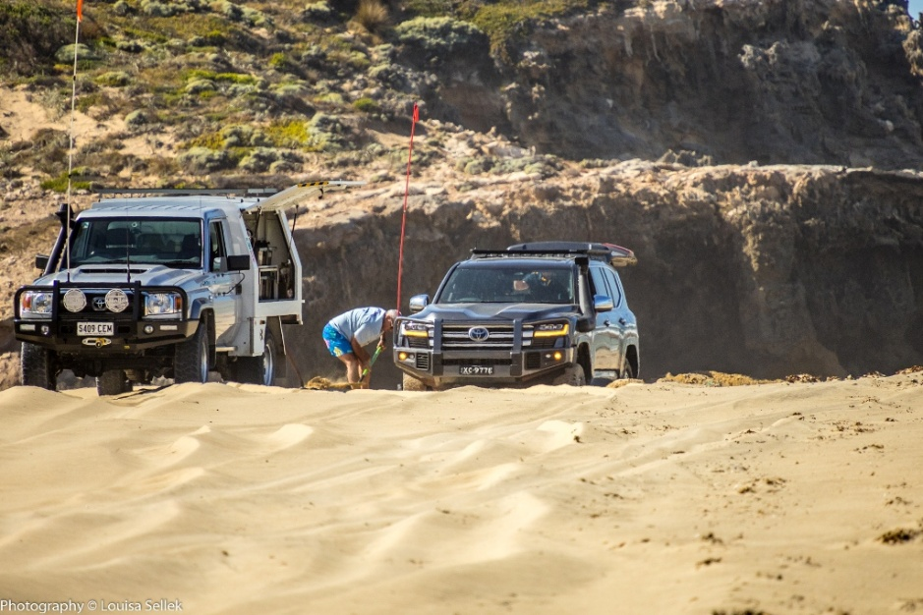

Impromptu smoko was had by many but by about 10:45am, we were underway again, and steady progress was made without either incident or geographical embarrassment. We got to the old bowl-shaped area and hillclimb behind Five Mile Rocks’ headland by 11:20am, seeing that it’s now almost completely filled by mobile sand, so no challenges there anymore, and the old car chassis buried in the beach just north of it was nowhere to be seen. The beach south of Euro Point was fine, and the long one north of it, in front of the Millicent Dune Buggy Club, was very “zen”.

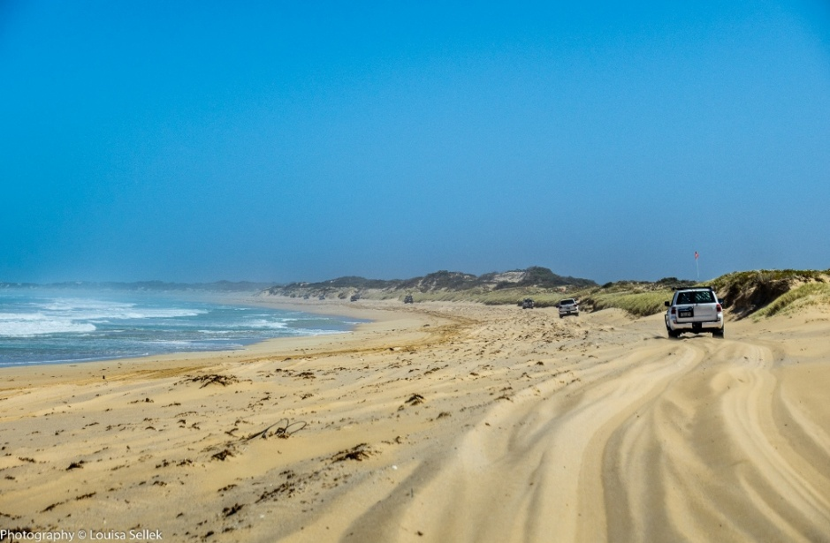

The Bluff and the four-way intersection behind it was reached before midday and caused a bit of confusion (turn left? Or hard left?), but the crowning achievement was getting the convoy through to the other side of The Cutting. This long, narrow, winding and challenging one-way headland bypass always has a potential for a train-wreck of congestion, confusion and delays thanks to encountering oncoming convoys in it – and this time also had a sideways sand drift over part of it, producing a less-than-comfortable side slope, though it looked worse than it ended up being. But all made it through by about 12:15pm without a single hiccup; bravo team. It was actually a good time to reflect on how we had been pretty lucky with other convoys, with there just not being as many around as in previous years, even on this long weekend – presumably partly due to the dune closures about 2.5 years ago. There was some other traffic north of here, though – including two clowns racing through the surf for laughs, and for future rust…
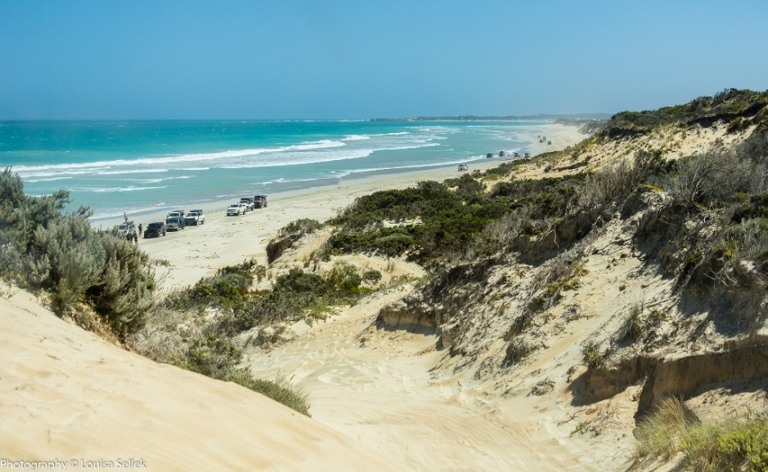

By about 12:20pm we were past Lurline Point and on the bypass track put in about three years ago. This cuts straight across to the main coast-parallel dirt road, thus avoiding Stinky Bay, the private shack-village of Nora Creina and, unfortunately, the lovely Nora Creina Bay – a great lunch stop in previous trips. A nearby replacement was found further up the dirt road at the Old Man Lake camping area, directly inland from Little Dip Beach. Somehow we all fitted, and somehow Tim issued more icecreams from the club.

By the time we left lunch it was getting onto 2pm, and this helped put paid to the idea of looping back a bit to try the challenging Little Dip Beach. This has three coves, with the middle one being steep, narrow and awkwardly hidden from either end – a combination that can result in a domino effect if just one vehicle gets in to trouble in that area, then others encounter it but can’t get past, and themselves come a cropper. Great fun, so a sad loss. We instead pushed on from the next beach north, then Long Gully Beach, Bishops Pate headland, Domaschenz Beach, various unnamed beaches and the bigger proportion in this area of often rocky inland bypass tracks – all until getting to the northern end of Back Beach at about 3:30pm, whose exit was “interesting”. It never seemed so in earlier trips, but was now steep, long and needing momentum to get past big diagonally-opposed holes at the very top – but complicated by a big oblique bump at the bottom which destroyed run-ups and pushed you offline when reversing for another go. The ominous sign of a new wreck was also at the bottom, an unfortunate SWB GQ Patrol which seemed to have been flooded. A full hour was spent getting the convoy up this exit, partly because it also got more dug-up as time went on. But great for the sake of science, with much experimentation with traction aids and tyre pressures. Rob’s eventual victory over it, after overcoming many earlier issues with bulk commitment, was especially good to see.

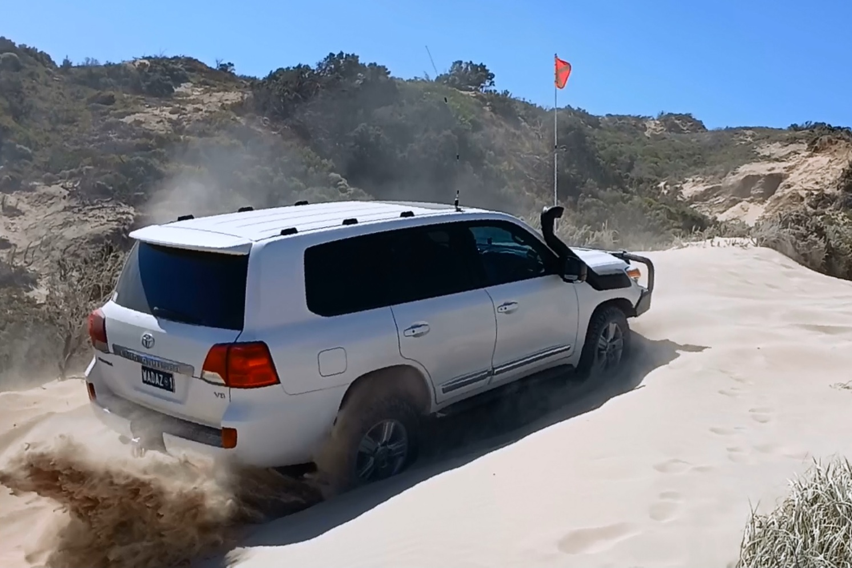

After all that, doing the one remaining beach before Robe seemed ambitious, so an early exit was taken up Stony Rise Track. The convoy aired-up then headed back to Beachport independently, with people doing their own thing that night.

Monday 26 January: Australia Day, with many choosing to attend the local community BBQ and ceremony. Some people left for the return journey after that, and others stayed on for another BBQ, this time by Tim on the beach.
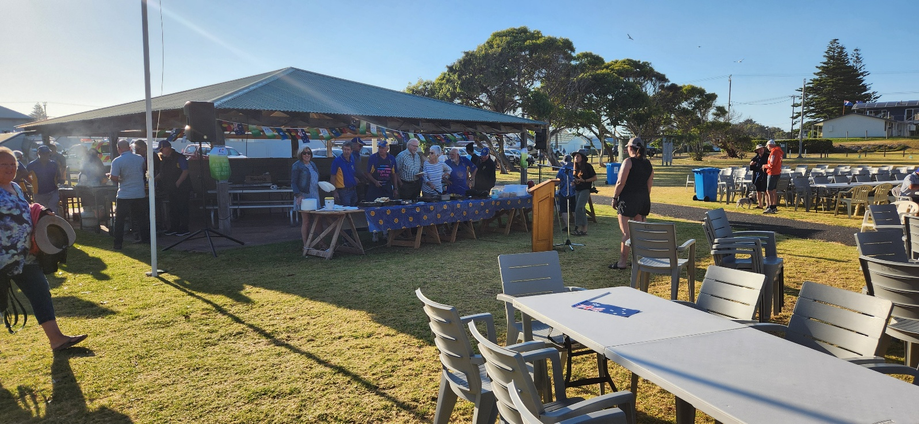
All in all a great trip to this very special area of our state!

